Keynote Address

Title: Cluster-Scaled Intelligent Data Analysis
Professor Dr Mika Sato-Ilic
University of Tsukuba,
Japan

Abstract:
Intelligence has been researched in different ways, such as research typified by brain science. However, artificial intelligence has also developed with a more engineering industrial target related to knowledge-based systems or soft computing paradigms. Analysis of vast amounts of complex data is necessary for acquiring human knowledge and its operation. Therefore, artificial intelligence has been developed with a close relationship to fundamental statistical analysis. Recently, this relationship has been further strengthened due to the existence of many complex data stored in computers where diverse and high performance are required by advanced practical products of the Internet of Things and smart computing systems.
In this talk, statistical intelligent data analyses which bind fundamental statistical analyses and advanced machine learning techniques in artificial intelligence paradigms are introduced with the idea of the effective utilization of clusters in data as the mathematical scales for measuring data structures. Several numerical examples applied to a vast amount of complex data are introduced to show the better performances of this idea.

Short Bio:
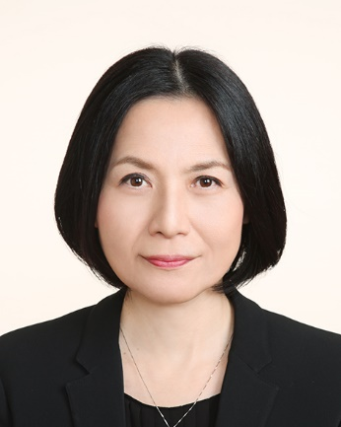
Prof. Mika Sato-Ilic currently holds the position of Professor in the Faculty of Engineering, Information and Systems, at the University of Tsukuba. She also holds the position of Vice President in the National Statistics Center, Japan and serves as a member of committee in the Financial Services Agency in Japan. She is the founding Editor-in-Chief of the International Journal of Knowledge Engineering and Soft Data Paradigms, Associate Editors of IEEE Transactions on Fuzzy Systems, Neurocomputing, Information Sciences, and Regional Editor of International Journal on Intelligent Decision Technologies, as well as serving on the editorial board of several other journals. In addition, she was a Council of the International Association for Statistical Computing (a Section of the International Statistical Institute), a Senior Member of the IEEE where she held several positions including the Vice-Chair of the Fuzzy Systems Technical Committee of the IEEE Computational Intelligence Society. In addition, she has served on several IEEE committees including the administration committee, program co-chair, and special sessions co-chair. Her academic output includes 4 books, 13 book chapters and over 120 journal and conference papers. Her research interests include the development of methods for data mining, multi-dimensional data analysis, multi-mode multi-way data theory, pattern classification, and computational intelligence techniques for which she has received several academic awards.

